3. Display Land Records

Table of Contents
Display Land Records 2
The “General” tab 3
The “Grand List” tab 5

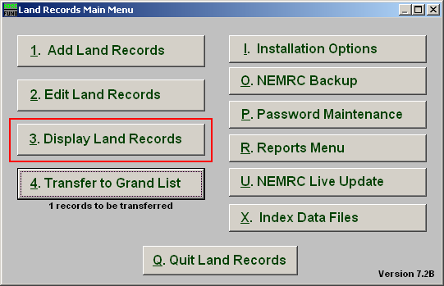
Click on “3. Display Land Records” from the Main Menu and the following window will appear:

Display Land Records

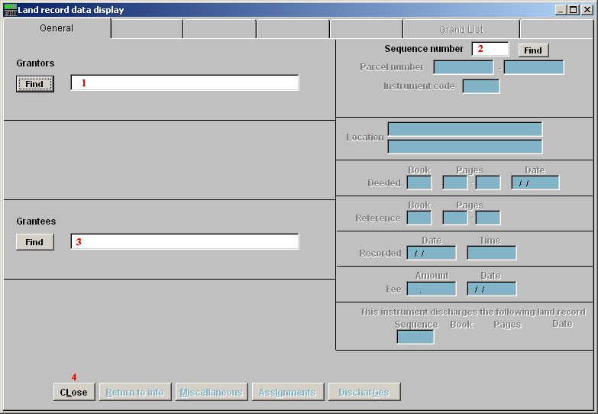
- Grantors: Type in the grantor name or click the “Find” button to select from the lookup table when locating a record by Grantor name.

- Sequence number: Enter the Sequence number OR click on the “Find” button to select from the lookup table when locating a record by number.

- Grantees: Type in the grantee name or click the “Find” button to select from a lookup table when locating a record by Grantee name.

- Close: Click this button to close with out saving changes and return to the previous screen.

The “General” tab

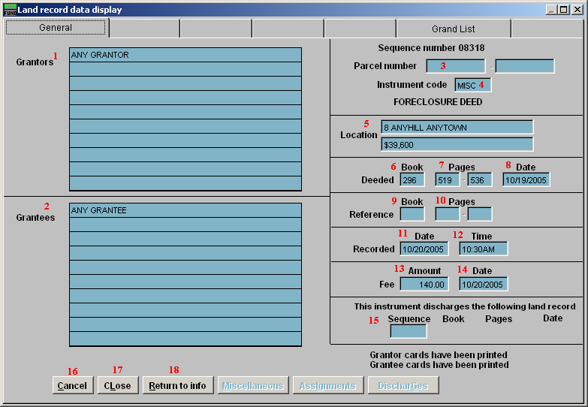
- Grantors: The display will show the names of grantors in the provided lines.

- Grantees: The display will show the names of grantees in the provided lines.

- Parcel number: The display will show the grand list Parcel ID if appropriate for this recording.

- Instrument code: The display will show the user defined instrument code.

- Location: The display will show the location of the property.

- Book: The display will show the book number this transaction is recorded in.

- Pages: The display will show the page number range this transaction is recorded on.

- Date: The display will show the date of the written document.

- Book: The display will show the book number of the reference, if appropriate, for this instrument.

- Pages: The display will show the page number range of the reference, if appropriate, for this instrument.

- Date: The display will show the date the document was received.

- Time: The display will show the time the document was received.

- Amount: The display will show the amount paid for recording the instrument.

- Date: The display will show the date the fee was paid for recording the instrument.

- Sequence: The display will show a previously recorded instrument when the current instrument is for discharging/releasing another instrument.

- Cancel: Click “Cancel” to cancel and return to the previous screen.

- Close: Click this button to close and return to the previous screen.

- Return to info: Click this button to open a window to show a return address this recording was sent back to.

The “Grand List” tab

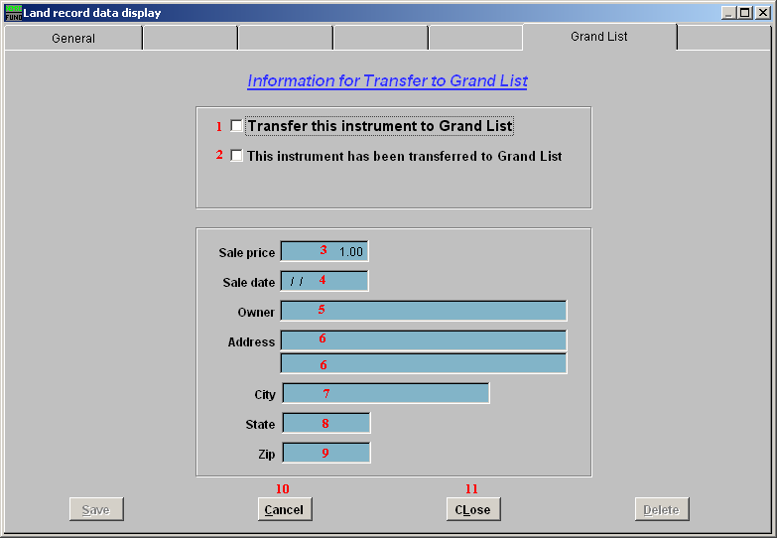
- Transfer this instrument to Grand List: The display will show this box checked to transfer the below information to the Grand List.

- This instrument has been transferred to Grand List: This box is checked after the instrument has been transferred to the Grand List.

- Sale price: The display will show the sale price of the property.

- Sale date: The display will show the sale date of the property.

- Owner: The display will show the new owner’s name to appear in the Grand List.

- Address: The display will show the new owner’s mailing address to appear in the Grand List.

- City: The display will show the new owner’s mailing city to appear in the Grand List.

- State: The display will show the new owner’s mailing state to appear in the Grand List.

- Zip: The display will show the new owner’s mailing zip code to appear in the Grand List

- Cancel: Click “Cancel” to cancel and return to the previous screen.

- Close: Click this button to close and return to the previous screen.

